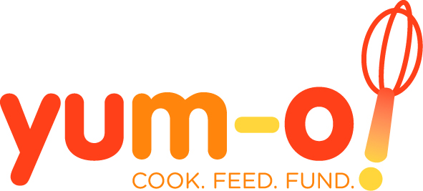

What is the Yum-o! Organization?
Launched in 2006 by Rachael Ray, Yum-o! is a 501(c)(3) nonprofit organization dedicated to teaching families to cook, feeding hungry kids and funding cooking education. By providing the tools to create easy, affordable and delicious meals, Yum-o! is changing the way America eats.

Yum-o!’s Mission
Yum-o! mission is to empower kids and their families to develop healthy relationships with food and cooking by teaching families to cook, feeding hungry kids and funding cooking education.

Our three work areas are:

COOK – Educating kids and their families about cooking
FEED – Feeding hungry American kids
FUND – Funding cooking education and scholarships

Why Yum-o!?
Today's kids and their families are pressed for time. Many don't know how to cook or assemble basic meals or are simply too busy and tired to spend much time in the kitchen. In addition, easy access to inexpensive food with low nutritional value has caused eating habits to deteriorate. Fortunately, most kids and parents are eager to make better food choices if given the necessary tools. Through its three core work areas of Cook, Feed and Fund, Yum-o! educates kids and their families about cooking, enabling them to explore the joy of food while making meals that are easy, healthy, affordable and delicious; teams up with partner organizations to feed hungry children; and funds innovative cooking programs in schools and educational opportunities for kids who are interested in pursuing careers in the food industry.
"Yum-o!" is the sound you make when you eat something really delicious. It is kind of a combination of "Yummy!" and "Oh wow!" You can't help but smile when you say it because it's such a fun word to say. A big part of the Yum-o! organization is about making cooking and eating something that makes people happy. Food should be delicious, fun and put a smile on your face.
Eating habits are formed at a young age and, if kids are given opportunities and knowledge, they will make better food choices. Yum-o! envisions a country where all kids realize the joy of cooking and eating great food.
Learn More About Yum-o!
The Yum-o! website at www.yum-o.org is the central place where Yum-o! provides information and tools to get people started, such as recipes, tips for the kitchen and ideas to inspire change in readers’ schools and communities. The Your Stories and How Cool is That? sections on the website offer opportunities for website visitors to tell us how they spend time together cooking and eating and about innovative programs in their schools and communities.
In addition to the interactive website community, Yum-o! also reaches out through its monthly e-newsletter and collaborative projects with its partner organizations (a list of current partner organizations is available at www.yum-o.org/partner.php). Printable takeaway items are also available on the website, such as the Yum-o! Kitchen Road Map, which can be hung up in the kitchen to keep easy reminders right at hand, or passed around at social events, schools and community centers to help spread the word.

Yum-o! is a tax-exempt, nonprofit organization as described in section 501(c)(3) of the
Internal Revenue Code of 1986, as amended. Our tax identification number is 20-8107545.

